

C:\Users\Rajat\Desktop\line.pngUTTAR PRADESHC:\Users\Rajat\Desktop\line.png

**In-House Practical Training Project Report on**

**IOT CANDLE**

Submitted to:

Amity University, Uttar Pradesh



by

**ARJEETA SINGH**

**(A2305216432)**

Under the guidance of

**MS. ABHA SACHDEVA**

**DEPARTMENT OF COMPUTER SCIENCE AND ENGINEERING**

**AMITY SCHOOL OF ENGINEERING AND TECHNOLOGY**

**AMITY UNIVERSITY UTTAR PRADESH**

**NOIDA (U.P.)**

**(2018-2019)**

**DECLARATION**

I, Arjeeta Singh, student of B.Tech Computer Science and Engineering, hereby declare that the project report entitled “iot candle” which is submitted by me to the Department of Computer Science and Engineering, Amity School of Engineering and Technology, Amity University, Noida, Uttar Pradesh in partial fulfillment of requirement for award of the degree of Bachelor of Technology in Computer Science and Engineering, has not been previously formed the basis for the award of any degree, diploma or other similar title or recognition.

Place: Noida --------------

Date ____________ **Arjeeta Singh**

(A2305216432)

**CERTIFICATE**

On the basis of the declaration submitted by Arjeeta Singh (Enrolment No.: A2305216432), student of B.Tech Computer Science and Engineering, I hereby certify that the project report entitled “IOT CANDLE”, which is submitted to the Department of Computer Science, Amity School of Engineering and Technology, Amity University, Noida, Uttar Pradesh in partial fulfillment of requirement for the award of the degree of Bachelor of Technology in Computer Science and Engineering is an original contribution with existing knowledge and faithful record of work carried out by him under my guidance and supervision. To the best of my knowledge this work has not been submitted in part or full for any Degree or Diploma to this University or elsewhere.

………………………

**Ms. Abha Sachdeva**

Assistant Professor

Department of Computer Science

Amity School of Engineering and Technology

Amity University, Uttar Pradesh

Date……………......

**ACKNOWLEDGEMENT**

Any project cannot be completed without the boundless assistance and motivation given by the faculties and the mentors. I would like to express my deep gratitude to Prof (Dr) Abhay Bansal, Professor and Head of department of Computer Science and Engineering, Joint Head, ASET and Director, DICET, Amity University for giving me this special opportunity to undertake and work on this project. A special vote of special thanks goes to Ms. Abha Sachdeva,assistant professor, CSE department, who has been a regular guiding force throughout the course of this project, and whose limitless support and cooperation has made the completion of this project possible. I deeply thank ma’am for her patience and kindness in working with me for this project and for motivation and inspiration she has given throughput.

Mentioning in the last but not the least, I would like to give a special vote of thanks to my family and other loved ones, who supported me through my shakes and shudders, both by keeping me harmonious and by helping me put the pieces together. I will be forever in debt of your support.

Arjeeta Singh

(A2305216432)

**Index**

* **INTRODUCTION**
* **LITERATURE REVIEW**
* **WHAT IS IOT**
* **IOT SYSTEM**
* **SCOPE OF IOT**
* **METHODOLOGY AND REQUIREMENTS**
* **TOOLS REQUIREMENT**
* **BRIEF OF TOOLS**
* **DESIGN AND IMPLEMENTATION**
* **SCHEMANTIC DIAGRAM**
* **PROCEDURE**
* **RESULTS AND DISCUSSION**
* **CONCLUSION**
* **REFERENCES**

..

**ABSTRACT**

This developed project i.e iot candle aims to show a beautiful and absolutely amazing and innovative candle using WIFI Module and RGB light. An IoT candle seems destined for the IoT bin.The candles are hot and dangerous but this product  is actually pretty cool, rather than warm. It’s like a light switched of tranformed to natural real flame candlelight.  The beautiful and outstanding innovative candle enables one to create the perfect ambiance for any occasion with the touch of a button and extinguish all your candles instantly as well. The candle appears as one of the best amalgam of tech , beauty, creativity and ofcourse need of the present day.

**INTRODUCTION**

Internet of Things (IoT**) “is a relationship of associated physical articles that are open through the web. The term 'thing' in IoT could be a man with a heart screen or a car with "worked in-sensors, i.e. objects that have been relegated an IP address and can gather and exchange information over a system without manual help or mediation or any sort of manual interference** “.The immersed advancement in the articles makes them connect with inside states or the outside condition, which in this way impacts the decisions taken. IoT incorporates widening web accessibility past standard contraptions, for instance, work zones, Personal Computers i.e PCs, Personal Digital Assisstant i.e PDAs and tablets(tabs), to any extent of generally nitwit or non-web enabled physical devices and customary articles. Embedded with advancement, these contraptions can bestow and coordinate over the web, and they can be remotely checked and controlled.

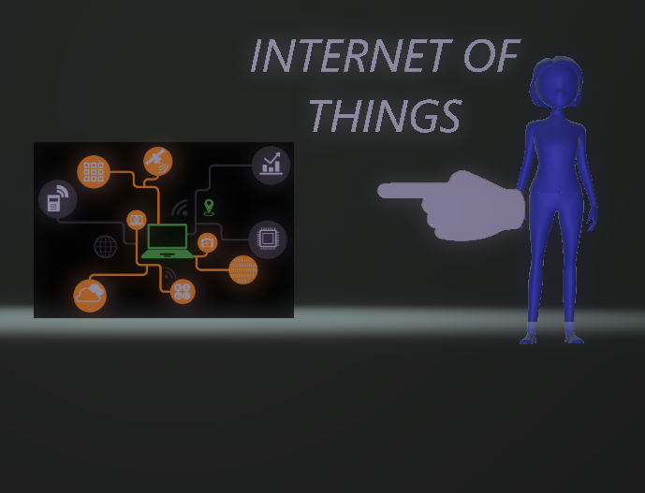

**IOT SYSTEM:** An IoT system or we can say the framework be made up of sensors/gadgets which "talk" to the cloud through some kinda of network. Once the information gets to the cloud, programming forms it and afterward may arrive at conclusion to play out an activity, similar to savvy sending an alarm or consequently changing the sensors/gadgets with no sort of intervension for the client**.**

Iot system works of the following :

* Sensors and devices
* Connectivity
* Data processing
* User interface

An IoT system constitute of various sensors/devices which "talk" to the cloud through a type of/some kind of system.Once the information gets to the cloud, software process and forms it and after that may choose to perform or carry out an activity, for example, sending an alarm or consequently modifying the sensors/gadgets without the requirement for the client.

In any case, if the client input is required or if the client basically needs to monitor the framework, a UI i.e user interface enables them to do as such. Any modifications or activities that the client makes are then sent the other way through the framework i.e through the system from the UI, to the cloud, and back to the sensors/gadgets to roll out some sort of improvement.

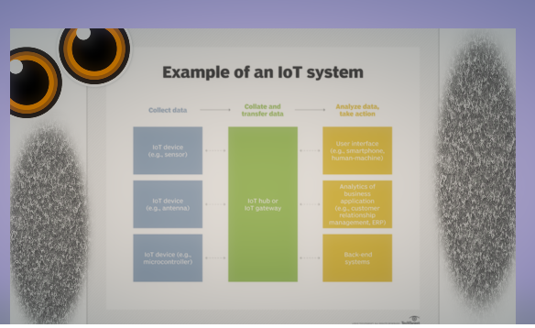

**WHAT IS THE SCOPE OF IOT**

Each thing or anything that fulfills the consumer industry became a word to buzz on. So seeing the present day internet feeds “Internet of Things” is surely one among thoseWhat it is - the ultimate objectives is to bring everything we use in everyday life over system and can be gotten to over the world over web. That implies each question/devices we use in an everyday life will have a distinguish over system and its data can be expends by means of Laptop, Tablet and versatile and including wearable like savvy watches.

Why we ought to do it - the above all else thing is robotization. In an average day, we as a whole have a 24 hours - 1/3 of time goes in bed, 1/3 of time goes in office/school and 1/3 third of time we need to spend for ourselves. How adequately are we investing this energy will have a gradually expanding influence on for the duration of the life

The iot covers all the possible domains of our everyday life and converts all the domain to so called “SMART”. Naming few out of them are:

* Smart home
* Smart farm
* Smart transportation
* Smart city
* Smart industry

IOT demonstrates to have an enormous degree as it gives a special chance to organizations to transform information into bits of knowledge. There are various contributing components also that drive the selection of IOT, for example, enhanced sensors, gadget associations, the development of way of life and versatility. These variables alone will drive the selection of IOT in India. By 2020, India's IOT advertise is relied upon to reach by USD 15 billion according to NASSCOM's report. To give an enhanced web involvement, numerous organizations and new companies have developed as large players in the IOT advertise. In India, almost 120 organizations and 70 % new businesses are putting forth IOT empowered arrangements. From 2015 till now, around 60 USD million has been put resources into IOT which has brought forth another method for working and living.

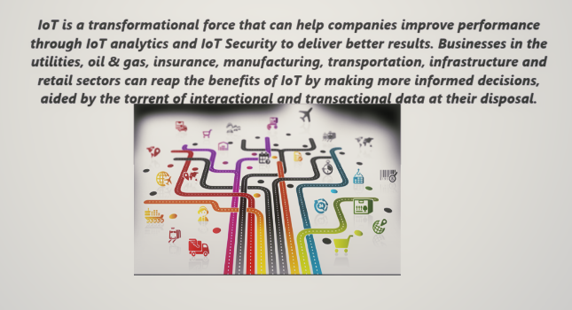

**TOOLS USED**

|  |  |  |
| --- | --- | --- |
| **Hardware components** | | |
| ESP8266 ESP-01 | |  | | --- | | “Everything ESP ESP8266 ESP-01” | |  | |
| SparkFun FTDI Basic Breakout - 3.3V | |  | | --- | | “SparkFun FTDI Basic Breakout - 3.3V” | |  | |
|  | |  | | --- | | “SparkFun ws2812b BreakOut” | |  | |
| Pushbutton switch 12mm | |  | | --- | | “SparkFun Pushbutton switch 12mm” | |  | |
| Jumper wires (generic) | |  | | --- | | “Jumper wires (generic)” | |  | |
| **Software apps and online services** | | |
| Arduino IDE | |  | | --- | | “Arduino IDE” | |  | |
|  | |  | | --- | | “Arduino core for ESP8266 WiFi chip” | |

**“HARDWARE REPRESENTATION OF THE CANDLE”**

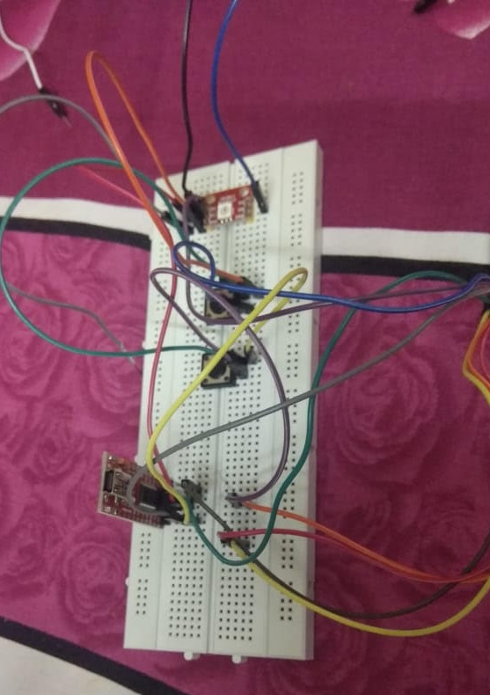

**BRIEF OF TOOLS**

**HARDWARE**

* **Everything ESP ESP8266 ESP-01:** ESP-01S is the upgradation of ESP-01 board.

Talking about the very and often used ESP8266 WiFi Module, it is a free SOC with facilitated TCP/IP tradition stack that can provide any microcontroller access to your WiFi sort out. The ESP8266 is set up to do either encouraging an application or offloading all Wi-Fi arranging limits from another application processor. “**This module goes with AT summons firmware which empowers you to get handiness like arduino wifi shield, at any rate you can stack unmistakable firmwares to make your own specific applicaiton on the modules' memory and processor**.” Its a to a great degree money related module and has an enormous and creating system reinforce.

This very hadware has narrowly accessible 80Mhz low power 32 bit processor which we can use for the various custom firmwares. This in like manner suggests you can have little site pages with no outside controller. For more unobtrusive components see : NODEMCU . **“The ESP8266 supports APSD for VoIP applications and Bluetooth coexistance interfaces, it contains a self-adjusted RF empowering it to work under each and every working condition, and requires no external RF parts.”**

ESP8266 is modifying the world with its negligible exertion and high features which makes it an ideal module for Internet Of Things (IOT). It can also be passed down as a piece of any application where you need to interface a contraption to your neighborhood framework or web. These little chips help you with beginning playing with WiFi frameworks! You can set this up as an entry or server, 24.75mm tall x 14.5 wide

* **SparkFun FTDI Basic Breakout - 3.3V:** This is a fundamental breakout board for the FTDI FT232RL USB to serial IC. The pinout of this board gets one work together the FTDI link to work with an official Arduino and cloned 3.3V Arduino sheets. It can likewise also be utilized for general serial applications. The real contrast which can be filtered with this board is that it draws out the DTR stick instead of the RTS stick of the FTDI link. The DTR stick enables the function to permits or allow an Arduino focus to auto-reset when any different Sketch is downloaded. This components appears to be a pleasant component to have and enables any draw to be downloaded without hitting the reset catch. This board provides the facility to self reset whichever Arduino board that has the reset stick passed on out to a 6-stick connector. The pins, to be specific BLK and GRN identify with the shaded wires on the FTDI connect. “The dark wire on the FTDI link is GND, green is DTR.” Utilize these BLK and GRN pins to adjust the FTDI essential board to your Arduino as a bull’s eye….”

Like each coin has two section so as this board ,there comes up the points of interest and disadvantages s to the FTDI Cable versus the FTDI Basic. Considering this very board, the board involve TX and RX LEDs that empower you to truly watch serial development on the LEDs to affirm if the board is working, yet this very board requires a Mini-B connect. The FTDI Cable is especially ensured against the portions, at any rate is wide and can't be brought into a meander as effectively. The FTDI Basic uses DTR to cause an apparatus reset where the FTDI associate uses the RTS flag. This board was required to diminish the cost of Arduino progress and expansion convenience. “The Arduino Pro and LilyPad sheets utilize this kind of connector."

* **SparkFun ws2812b BreakOut:** The mentioned is a breakout board for the WS2812B RGB LED. The WS2812B (or "NeoPixel") is really a RGB LED with a WS2811 incorporated ideal with the LED! All the coal and ice i.e fundamental pins are broken out to 0.1" divided headers for simple bread-boarding. A few of these breakouts can even be anchored in sync to frame a show or an addressable string. What knock offs the WS2812B extremely extraordinary is the manner in which its controlled. The IC installed into the LED divulges by means of an notably remarkable one-wire interface. With the reinforcement of a few librariesas a helping hand, they're simple to nth degree to control. In augmentation they're chain-capable – the yield of one LED can be associated with the significant addition of another to make segments of several LEDs. The more sheets you have connected together, the fancier your hustle can be!

In this instructional exercise we will get you snug as a bug in a rug in short comfy with the workings of the WS2812 and WS2812B. We'll go over a piece of action of the manners in which one should requisite to connect to the breakout board, LilyPad, or strips.

* **SparkFun Pushbutton switch 12mm:** This is a standard 12mm square transitory catch. What we extremely like is the substantial catch head and great material feel (it 'clicks' extremely well). This catch is incredible for client contribution on a PCB or a decent, enormous reset catch on a breadboard. Breadboard neighborly!!

**Jumper wires (generic):** On the off chance that you have to thump up a brisk model there's not at all like having a heap of jumper wires to speed things up, and let be honest: once in a while you need amount over quality. These are a similar jumper wires that accompany the SparkFun Inventor's Kit, they're less rough than the superior jumper wires however they're extraordinary for bread-boarding, they're more affordable and we offer them in packs of 30! They may not hold up to quite a long time of manhandle however they're a decent esteem and we utilize them all the time here at SparkFun, both in classes and individual undertakings. Your pack of 30 jumper wires will be an arbitrary combination of different hues.

* The dimension of the cables here ranges from about 20cm

8-inch.

* Jumping wire has two ends, namerly male and female, on one hand the male ends are meant for insertion into the standard which is about0.1 inch (2.54mm) in length and on the another hand the other end which is the female sockets , these ends are meant for insertion onto the standard 0.1 inch (2.54mm) male headers.
* These jumping cables/wires can also be segmented to form a compile containing the various number of wires one require for the desired connection and also to be a back in the form of support to the non-standard and the odd-spaced headers.

**SOFTWARE**

**ARDUINO IDE**: The Arduino IDE (Integrated Development Environment), put essentially, is nature where you can compose Arduino code, accumulate it and transfer it to your Arduino or Arduino perfect board.You can download it in Arduino - Home and introduce it for PC, Mac or Linux - then its a matter of module your Arduino to your USB port and begin having a great time! Arduino IDE contains two things - Arduino and IDE. We should discuss these one by one.

Arduino is a smaller scale controller advancement board arrangement - Uno, Mega, Nano, Mini and so on are a couple of illustrations. Presently, any smaller scale controller(here it is the Atmega 328 IC on the Arduino Uno or Atmega 1280 on arduino Mega) that should be modified is essentially nourished with a hex code adaptation of the code written in abnormal state (English) dialect. In this way, arduino improvement sheets are sustained with the code by means of their Arduino IDE.

Presently, IDE (Integrated Development Environment) is essentially a product that empowers better and helped code altering, incorporating and investigating. The Arduino IDE keeps running on the Java Platform. You can co-relate this to Eclipse, which is another IDE for Java. So the dialect java has diverse IDEs that facilitate the utilization of the dialect for a specific reason. Nonetheless, Eclipse doesn't bolster the capacities and orders that work on arduino board. Thus, this Arduino IDE fundamentally has inbuilt capacities and charges that however take a shot at Java stage, are redone to keep running on the arduino dev. board. In this manner Arduino IDE serves for code altering, its aggregation, investigating and after that consuming the code into the arduino dev. board. “**The well known Arduino Integrated Development Environment or commonly known Arduino Software (IDE) – comprise of a word enhancer or best call a word processor which is used for composing code, along with that a message region, a content reassure. with that a message locale, a substance console. Additionally it has a toolbar with gets for essential limits and a movement of menus. It's among one of the people between the Arduino and Genuino hardware to exchange the projects and talk with them”.**

**Arduino core for ESP8266 WiFi chip :** ESP8266 Arduino core punch the clock with barious libraries to keep in touch over WiFi using TCP(transfer control protocol) and UDP. It makes provision for HTTP, mDNS, SSDP, and DNS servers. Not only these but also performs the known OVER THE AIR popularly known to be the **“OTA”** updates, use a file system in flash memory. It functions well with Arduino SD cards and servos. It’s performs task like Serial Peripheral Interrface i.e SPI which is a synchronous protocol and I2C peripherals.Along with all the mentioned perks ,it comes up with the facility of wireless System on Chip (SoC). It has digital pins called GPIO, I2C,analog to digital convertor( ADC),serial peripheral interface (SPI), pulse with modulation (PWM) and quite a few more. It's working at 80MHz.64KBytes of guideline RAM + 96KBytes of information RAM. 64KBytes boot ROM.It additionally jump up with Winbond numbered W25Q40BVNIG serial pheripheral interface i.e SPI streak. It's a "RISC" development.It also spring up with Winbond numbered   W25Q40BVNIG  serial pheripheral interface i.e SPI flash. It's a “RISC” construction . In this chip the very core 106micro Diamond Standard core (LX3) built in by the  Tensilica. The ESP8266 chip is sdeveloped/ given by the  Express. Modules keeping/having/bearing this chip are formed(developed) by the various manufacturers.

The chip is a versatile innovation and bears following features:

* Chip’s “**802.11 b/g/n protocol, Wi-Fi 2.4 GHz, support WPA/WPA2. Super small module size (11.5mm x 11.5mm)**.”
* Comes up with assimilated 10-bit Analog Digital Converter.
* Have facility of compact Transation Control Protocol/Internet Protocol protocol.
* Clubed together are the TR switch, balun, LNA and power amplifier.
* Matching network/system Integrated PLL, regulators, and power controll/ management units.
* Has a output power of +20dBm.
* Antenna diversity
* Sleep power comes up to be less than 10uA.
* Power dropper leakage current is in this module , less than 5uA.
* Low power 32-bit MCU
* HASSDIO 2.0 and SPI
* HasUART and  I2C
* HASSTBC, 1x1 MIMO, 2x1 MIMO
* BearsA-MPDU & A-MSDU aggregation & 0.4μs guard interval
* It’s **“Wake up and thetransmit packets in less than 2ms”**
* Provides with the facility of standby power utilisation or we can say consumption of even less than 1.0mW.
* It’s Operating temperature range between -40C ~ 125C

**SCHEMATIC DIAGRAM**

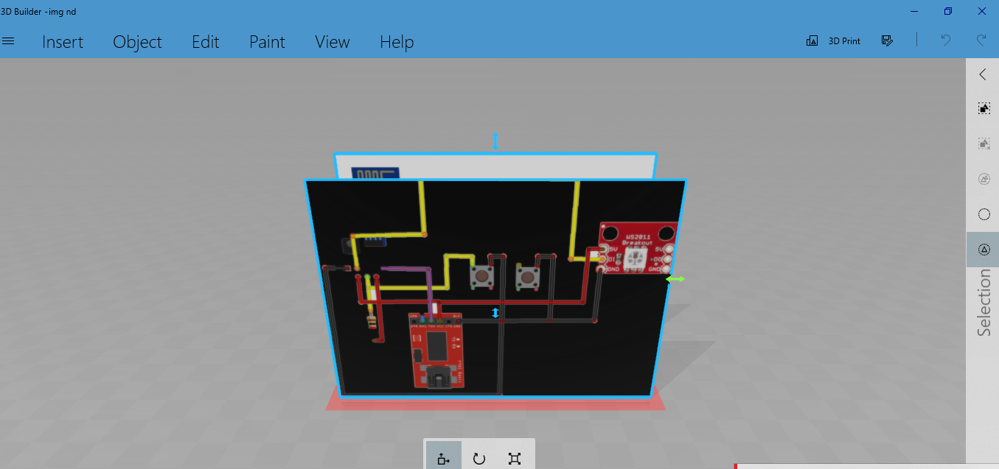

**PROCEDURE**

I was given this in house project and seing the latest demand of IOT in the it sector i was so keen to develop something related to the same. Chips,ICs and all have always interested me so , for some time now, I wanted to create some project with the WS2811 Breakup. And I this time i thought to get down to work, using as a basis the work of ancient lightning source that is the workshop building a lantern in a Ball jar with a mixture tinch of an Adafruit NeoPixel and Gemma board.

The IOT CANDLE as the same suggest is the candle but surely not like other candles it got techy features.

The methodology of making the creation was very simple and easily understandable .

STEPS INVOLVED IN THE DEVELOPMENT:

* Gathering together all the necessary hardware mentioned above
* Installing the Arduino IDE
* Installing the ESP8266 WIFI chip to our coded sketch.

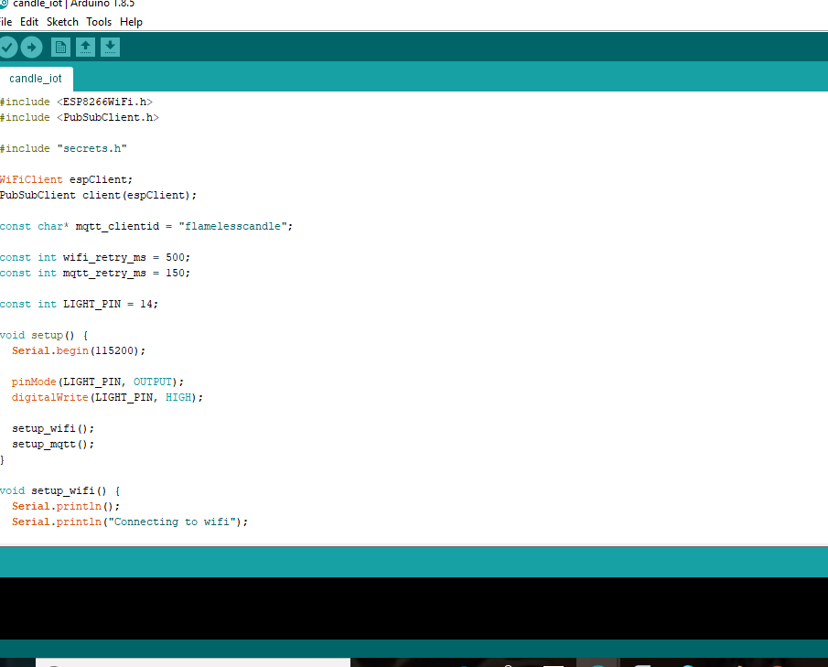

* Arranging all the hardwares in the given schemantic diagram above with the help of jumper wires

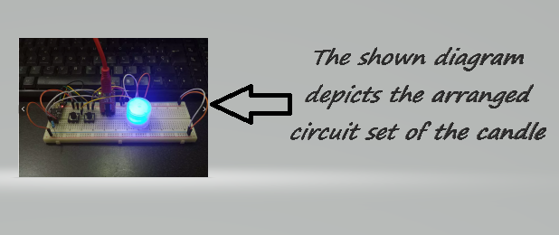

* And hence we come up with the magical techy candle.\

**BENEFITS**

* Obstreperous technologies are frequently bring into the frame with the difference in the invention/ creativity from the Beautified Candle to the very necessary Lightning Bulbs. The story here by especially focuses on the fact that it”s necessarily not possible that always innovations can come up as an improvement/improvision of the state of the art / matter technology but at times some different or we can say hidden technology become widely viral in the market and some fields or industries, if not ready, are overshadowed by the new era technology and are totally repossessed in their main or we can say their core task or function.If we look around us we’ll still find that we do have candles today, but many think rather no one thinks to light up the house with these very pretty creation , ya ofcourse except on diwalis....,since earlier it was among one of those few sources of light people consider it very important but eventually with the great development the candle became a cranny market with some what different purpose and greater selvage ; i.e. pretty bright coloured and sweet fragrance rich candles used for allurement/ attraction more than exigecy as a light source

“IoT (Internet of Things) “ is the appellation that involves a wide range / group of so many trending technologies/ automations naming few of them like bluetooth, zigbee, wifi which later on became obstreperous the reason behind this obstrepertion was their low/diminished cost. The Internet of Things (IoT) has turned over a new leaf on us, our apprehensions, our brainchild and the way we get across with the “things” . This is sweeping newness/ contraption and is enabling opportunities/chances across all the possible industries. The hawk zone is not contrary to this change/transformation. Retailers all around the globe are venturing with iot in order to amiliorate their works/ operations and bring in a serene and frictionless shopper experience. Once the sectors get habituate to the innovations, IoT is brood to create and come up with numerous opportunities for retailers in remodelling customer experience along with broadening and booming the operational efficiency and also generating new business tributaries.

An IoT candle appears in the cards for the IoT bin, but this artifact  is actually daintly cool, rather than warm.

In as much as castle builder and romantics who loves to paint the town basking in the glow of natural smoldering remains, these self igniting candles – with wirey stuff – could be time savers. Not only time but eventually these will gonaa also save your money by automatically extinguishing themselves after a certain amount of time and tendency of being used again again .

On the other hand even those among the crowd who never saw a why and wherefore in candles clout ,get up and go enjoy loving and get use to it and even falling asleep to the warm incandescene or blush or waking up to a sweet tempered scent.

The developer says that the candle comes up with safety issues by not allowing or prohibiting (or extinguishing) the candle’s flame if the candle is being wrongly kept . With the cute nob the objects are never prone to be burnt or even being detected in any of the so called “burn zone.”

The candle appurtenance is meaningfulness expensive.

The very special open and shut pending Wi-Fire Smart Module communicates wifi to our product. The product has various perks along with the features allowing the customer to inlighten and extinguish our propriertorship specifically the particularize 100% no wax structure . There is no dangerous, flammable gas either—it’s just a souped up version of real candle!

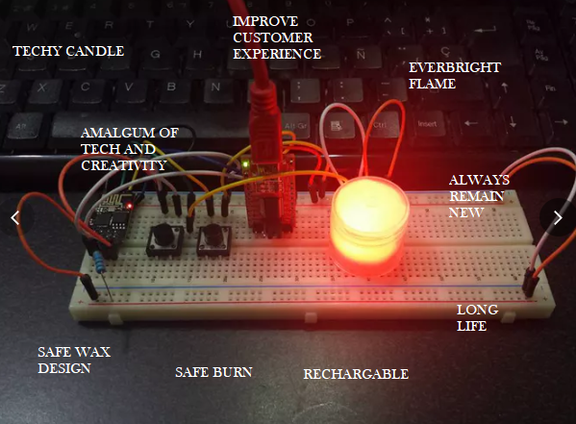

**CONCLUSION**

I hereby conclude that the In – House project on my selected topic is been developed fulfilling the aim of the same.. The knowledge of Arduino from this project going to help me alot in the future and ofcourse the iot things.The project hence solves the problem of candle in very techy manner.

The project provides various features like :

* Everbright flame
* Burn proof
* No wax
* Rechargeable
* Remain new
* Long life and many more...

Also the use of various hardware enables the developer to learn electronics and digital electronics and team it up with computer science.

**REFERENCES**

The following sites helped me to build my project more effectively and learn it in better manner.

* https://learn.adafruit.com/pir-passive-infrared-proximity-motion-sensor/using-a-pir-w-arduino
* https://www.wikipedia.org/
* https://github.com/esp8266/Arduino
* https://protechitjobs.com/10-of-this-years-strangest-iot-internet-of-things-products/